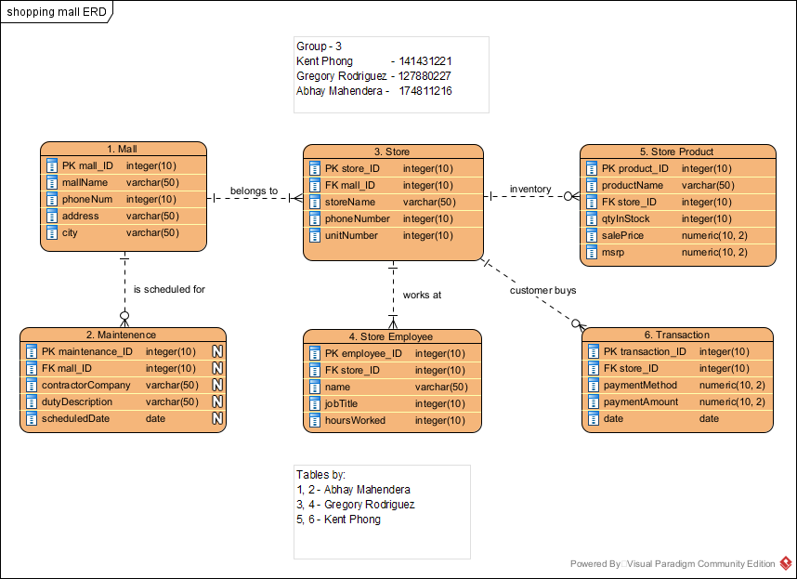

**Mall relationships:**

* A mall has 1 to many stores inside of it; A mall without a store doesn’t exist.
* A store can only belong to exactly 1 mall.
* A store has zero or many products depending on their stock.
* A product belongs to exactly 1 store; A similar product being sold elsewhere will have a different product_ID.
* A store can have zero or many transactions.
* A transaction belongs to exactly 1 store.
* A store has 1 or many employees that work for it otherwise it means its closed permantly.
* A store employee is only allowed to work at exactly 1 store because mall policy.
* A mall contracts zero or many maintenance services.
* A maintenance service only happens at exactly 1 mall.